import pandas as pd

from sklearn.neighbors import KNeighborsClassifier

from sklearn.ensemble import GradientBoostingClassifier

from sklearn.model_selection import train_test_split

from sklearn.metrics import accuracy_score

#Eliminar warnings

import warnings

warnings.simplefilter("ignore")

dt_heart = pd.read_csv('heart.csv')

y= dt_heart['target']

x= dt_heart.drop(['target'], axis=1)

x_train, x_test, y_train, y_test = train_test_split(x,y,test_size=0.35)

estimators = range(10, 200, 10)

total_accuracy = []

for i in estimators:

    boost = GradientBoostingClassifier(n_estimators=i).fit(x_train, y_train)

    boost_pred = boost.predict(x_test)

    total_accuracy.append(accuracy_score(y_test, boost_pred))

import matplotlib.pyplot as plt

plt.plot(estimators, total_accuracy)

plt.xlabel('Estimators')

plt.ylabel('Accuracy')

plt.show()

#plt.savefig('Boost.png')

import numpy as np

print(np.array(total_accuracy).max())

|  |  |
| --- | --- |
|  | IMPLICA QUE CUANDO LLEGA A 150 ESTIMACIONES YA NO AUMENTA MAS LA EXACTITUD  Si da  estimators = range(150, 400, 150)  Da una recta ??? |

boosting = GradientBoostingClassifier(loss='exponential',learning_rate=0.15, n_estimators=100, max_depth=5).fit(x_train, y_train)

estimators = range(150, 400, 150)

total_accuracy = []

for i in estimators:

    boost = GradientBoostingClassifier(loss='exponential',n_estimators=i).fit(x_train, y_train)

    boost_pred = boost.predict(x_test)

    total_accuracy.append(accuracy_score(y_test, boost_pred))

import matplotlib.pyplot as plt

plt.plot(estimators, total_accuracy)

plt.xlabel('Estimators')

plt.ylabel('Accuracy')

plt.show()

plt.savefig('Boost.png')

import numpy as np

print(np.array(total_accuracy).max())

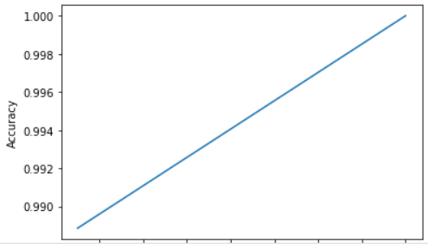

**loss*{‘deviance’, ‘exponential’}, default=’deviance’***

The loss function to be optimized. ‘deviance’ refers to deviance (= logistic regression) for classification with probabilistic outputs. For loss ‘exponential’ gradient boosting recovers the AdaBoost algorithm.

**learning_rate*float, default=0.1***

Learning rate shrinks the contribution of each tree by learning_rate. There is a trade-off between learning_rate and n_estimators.

**n_estimators*int, default=100***

The number of boosting stages to perform. Gradient boosting is fairly robust to over-fitting so a large number usually results in better performance.

**subsample*float, default=1.0***

The fraction of samples to be used for fitting the individual base learners. If smaller than 1.0 this results in Stochastic Gradient Boosting. subsample interacts with the parameter n_estimators. Choosing subsample < 1.0 leads to a reduction of variance and an increase in bias.

**criterion*{‘friedman_mse’, ‘squared_error’, ‘mse’, ‘mae’}, default=’friedman_mse’***

The function to measure the quality of a split. Supported criteria are ‘friedman_mse’ for the mean squared error with improvement score by Friedman, ‘squared_error’ for mean squared error, and ‘mae’ for the mean absolute error. The default value of ‘friedman_mse’ is generally the best as it can provide a better approximation in some cases.